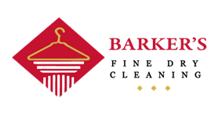
FREE* PICK-UP & DELIVERY SERVICE!
Barker’s Fine Dry Cleaning is offering a FREE pick-up and delivery service whether at your office or your front door. Simply drop your “Convenient Bag” before 10:00 am at your pick-up location and we will do the rest!

*Please note there is a minimum of $35.00 value + taxes.

Your pick up & delivery day will be base on your address.

Call in:
Call 403 282 2226 before 9:00am on the morning of your pick up day.

Your Contact Information:

Client Name: ______________________________Company Name: ________________________________

Daytime Telephone: Mobile:____________________________ Office: ____________________________
Address: ________________________________________________Postal Code:______________________
Instructions: Hanged Folded Shirts

Comments:_______________________________________________________________________________

CREDIT CARD AUTHORIZATION
I___________________________________________________, hereby authorize Barker’s Fine Dry Cleaning to use my credit card for payment of dry cleaning or laundry service.
Cardholder’s name (as it appears on the Card):____________________________________________________
Credit Card: VISA _____ MASTERCARD ______ AMERICAN EXPRESS______
Card Number _____________________________________________________________________________
Expiry____/______ CVC2 Code_____ (last 3 numbers printed into the signature panel on the back of Visa, MasterCard. For American Express it is a four-digit code imprinted above your card’s number on the front.
Cardholder’s Signature: ____________________________________________ Date:_____________________
* * *
Thank you for choosing Barker’s for your Fine Dry Cleaning needs!

